

**Bachelor Project Report**



**SportLook**

***A social network for sport events***

**Date**: 1 June 2015

Alexandru-Cosmin Vasile, [168134@via.dk](mailto:168134@via.dk)

Ibrahim Yildirim, [166802@via.dk](mailto:166802@via.dk)

Juraj Petrik, [166740@via.dk](mailto:166740@via.dk)

**Supervisor**: Jan Munch Pedersen, [jpe@via.dk](mailto:jpe@via.dk)

Table of Contents

**Abstract** 3

**1.** **Introduction** 3

List of figures and tables goes here

List of code snippets goes here

# **Abstract**

*The objective of the project was to develop a client-server system, where users can interact through the client (iOS application) and socialize around the topic of sport events.*

*Each component of the system was chosen to support the mobile applications environment. The client was developed using the iOS SDK and user interface components provided by the Cocoa Touch framework. This allows for a high performance and a favourable user experience.*

*The outcome of the project is a fully functional system, which allows users to interact as expected. All of the system components have been deployed successfully and the client is available for download in Apple's AppStore (digital distribution platform for mobile applications).*

*The result is a system that can support a moderate amount of users, further work being needed for a larger user base. The mobile application benefits from exposure to the public and it has the potential of becoming a popular and successful social application.*

# **Introduction**

The project will cover the development of the iOS application named *SportLook*, optimized for iPhone devices. The application is a renewed version of an already existing iOS application named [*MoveBizz*](http://movebizz.dk/), which was available in Apple's AppStore. MoveBizz provides its users with the opportunity to meet other people who share the same sport interests through sport events. Unfortunately, the application lacks good functionality and good user experience. The concept of the application is that its users can create sport events and other users can view these events and all related information to the events such as name, date, location, participants etc.

The objective of this project is to build an iOS application, optimized for iPhone devices, that can share data between users. It builds on the concepts of MoveBizz, but will benefit from extra functionality which will be documented.

## **Project Environment**

The outcome of this project will be an iOS application, which is a requirement from the company *Move Sport* (further addressed as the client). The client originally had the idea of this concept and hired a development team to create the first version - MoveBizz. Unfortunately, the end product is not a stable system and it cannot be used properly for its purpose due to poor performance.

The application will present users with sport events in their area, and then give them the opportunity to join the event and interact with the other participants. One of the requirements from the client is that the server can communicate with different mobile operative systems. The reason for that is because the client hired another development team ([AppUdvikleren.dk](http://appudvikleren.dk/)) to build the Android version of this application. During the development of SportLook the current development team had to coordinate with them in order to make the application have a similar user interface and similar functionality, as present in the iOS application.

The segment of users of this application are both genders in the age group of 12 to 65 and have an active lifestyle or want to socialize through a game of football, chess or different activities. A common person wants to meet other people that share the same sport interests as themselves.

# **Analysis**

## **Requirements**

The requirements have been divided into functional and non-functional, as follows:

*Non-functional*

* Application must be an iOS application, optimized for iPhone devices.
* Application must support iOS versions 7.1 - 8.3.
* Application must support all iPhone screen sizes (iPhone 4, 4S, 5, 5S, 6 & 6 plus).

*Functional*

* The user must be able to find sport events close to his location.
* The user must be able to view details about any sport event.
* The user must be able to create an event.
* The user must be able to join / leave an event.
* The user must be able to send messages to people that have joined the same event.
* The user must be able to invite users to events.
* The user must be able to change his profile information.
* The user must be able to find other users with similar interests close to his location.

## **Domain Model**

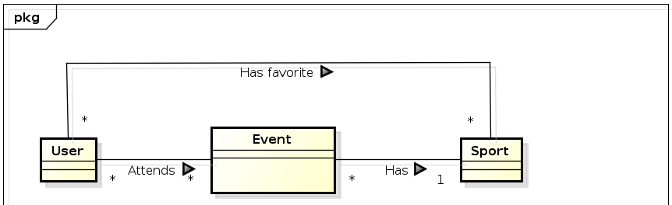

**Figure 1. Domain model**